**EXPERIMENT 2**

Name: M.S.SANJAY Reg. No.: 15BCE0517 Slot: L31+L32

**Challenging Experiment 2**

**Create your own (Student Record) dataset and do the summary statistics and graphs with interpretation. Use at least 50 observations with five variables.**

**The five variables used are “age”, “gender”, “married”, “child” and “income”.**

age=c(16 ,23 ,24, 45, 13, 46, 35, 27, 36 ,17, 15 ,28, 25, 23 ,15 ,26 ,16, 19, 30, 20, 25, 24, 17, 18, 18,

36, 27, 18, 19, 20, 21, 23, 26, 23, 16, 19, 27, 28, 17, 34, 31, 30, 20, 21, 24, 18, 19, 17, 26, 33)

gender=c( 0 1 0 0 1 1 1 0 0 1 0 1 0 0 0 1 0 1 1 0 1 0 0 1 0 0 1 1 1 0 1 1 0 0 0 1 0 0 1 0 1 0 1 0 0 1 1 0 0 1)

married=c(1 0 0 1 1 0 0 1 0 1 1 0 0 1 0 1 0 0 0 1 1 0 1 0 0 1 1 1 0 1 0 0 1 0 1 0 0 1 1 0 1 0 0 1 0

0 1 1 1 0)

child=c( 1 0 2 3 1 2 1 0 2 1 0 2 2 1 1 0 1 0 1 0 2 3 0 3 1 2 2 1 3 0 0 0 1 0 1 2 3 2 0 2 2 1 0 3 1

2 1 2 0 1)

income=c( 20 12 13 27 45 34 27 26 47 56 43 30 21 22 43 18 29 35 42 41 34 27 26 18 15 11 20 32 30 4 59 36 34 24 27 26 32 19 17 43 20 27 19 10 21 32 33 53 20 19)



data=data.frame(age,gender,married,child,income)

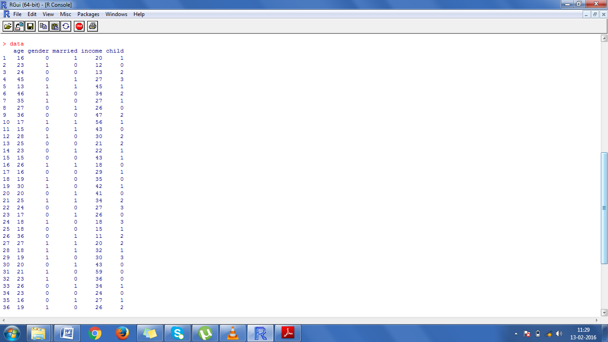



**Graphical representation of the age of the chosen subjects.**

Plot(data$age,type=”l”,main=”Age of Subjects”, xlab=”data”,ylab=”age in years”,col=”blue”)

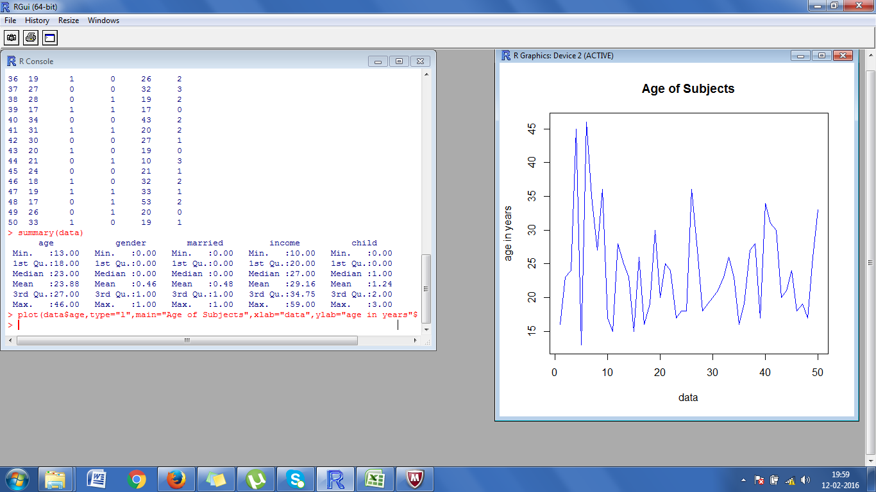

**Graphical representation of number of children each subject has (pie chart)**

table1<-table(data$child)

pie(tabe1)

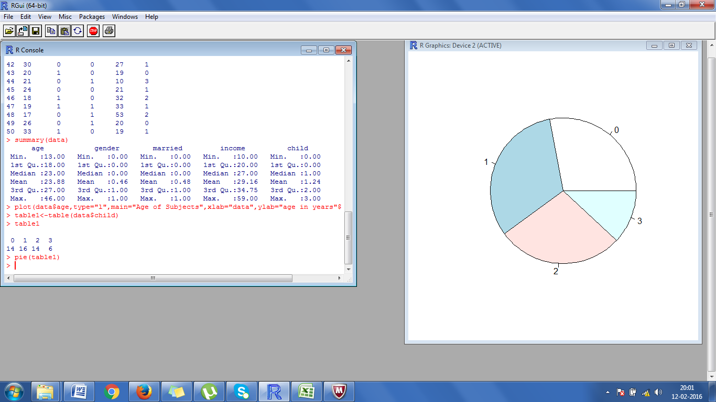

**Graphical representation of married and gender through bar graph**

table2=table(data$married, data$gender)

barplot(table2,beside=TRUE,col=(“blue”,”red”),xlim=c(0,20),ylim=c(0,20))

legend(“topright”,legend=rownames(table2),fill=c(“blue”,”red”))

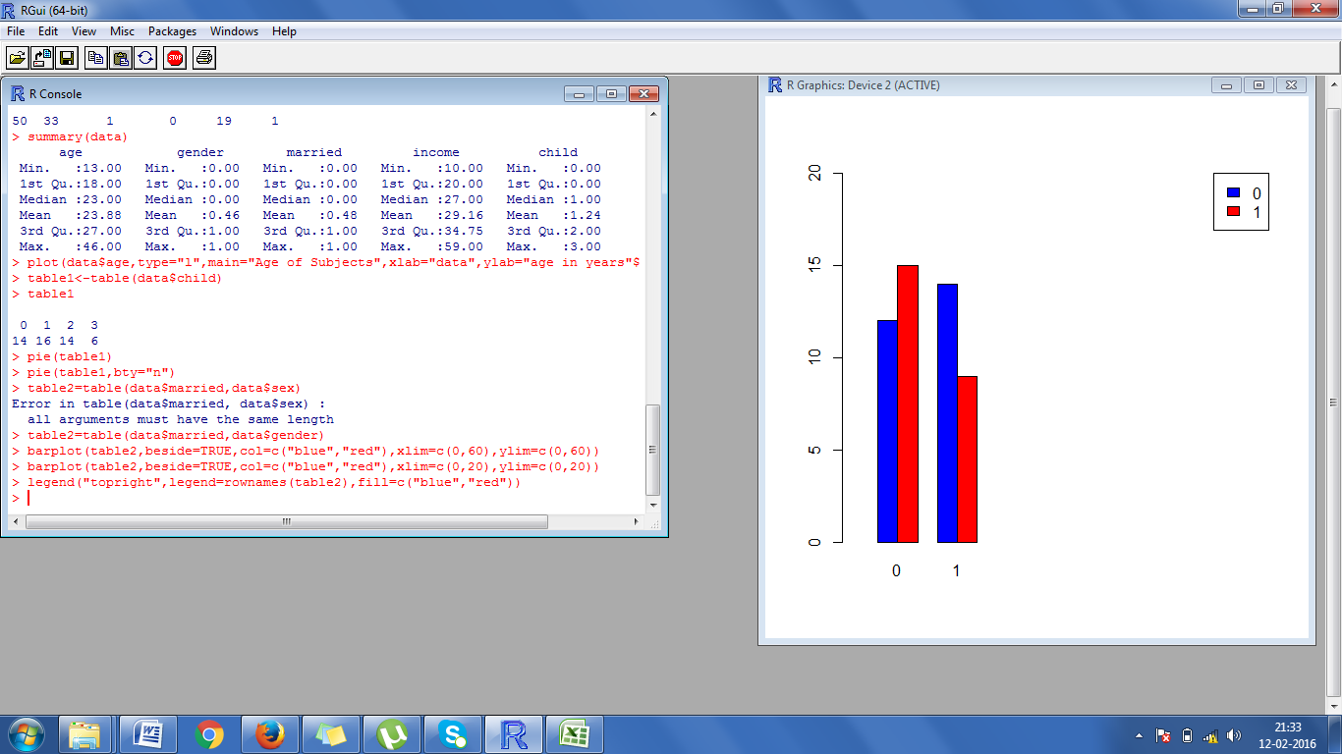

**Summary statistics of data**

